FALL 2018
SEPTEMBER
NEWSLETTER
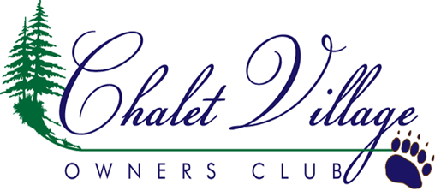
2018-2019 CVOC BOARD OF DIRECTORS

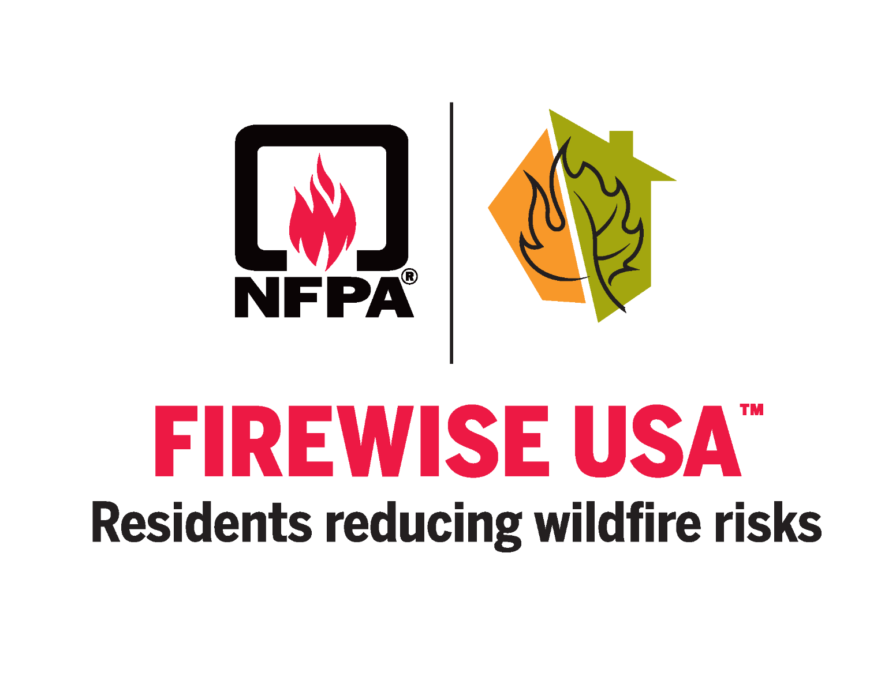
CVOC is a fully functional, nationally recognized Firewise community! Thanks so much to Pete and Joy Jucker for leading the charge. It takes a lot of hard work and dedication to get a program like this off the ground and Pete and Joy did an amazing job leading the team. We have a Firewise committee in place but we ALWAYS need volunteers. We received a grant to purchase the tools and equipment we need and have volunteer “overseers” trained in Firewise principals ready and willing to assist our homeowners make their properties Firewise.

Our first Firewise Awareness Fair was held on April 28, 2018. We had an amazing turnout. A lot of valuable information was provided by Tennessee Department of Forestry, the Gatlinburg FD, and our own Firewise Committee. Following the Firewise awareness Fair, we hosted our first Firewise Clean-Up work weeks. We had several homeowners sign up and the committee and volunteers put in the hours to get the job done.

What we need from you is simple. PARTICIPATE. Get in contact with Pete at petejucker@gmail.com, or join the Chalet Village Firewise Community Facebook page and message him your Firewise need or your willingness to volunteer. If you need Firewise work, once we can get you in the schedule, you simply need to supply the labor of a few friends or family. The Firewise group will provide leadership, tools and equipment depending on the need and volunteers if available.

There is much work still to be done to improve our community. The resources are available. If you need assistance, please get in touch and let the committee know your need. Also, please consider signing up to be a working volunteer! Remember: Many hands make light the work! Please consider being a part of this beneficial program.

CVOC FIREWISE 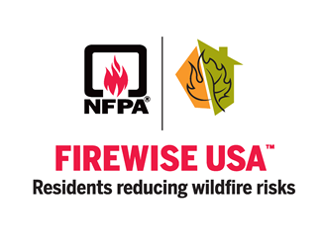
*Ken Webster, President
Patrick Potter, Vice President
Pam Betts, Secretary
*Stan Johnson, Treasurer
Bob Light, Director
*Dean Phillips, Director
Rebecca Helton, Director
*up for re-election in April

OKTOBERFEST
This year’s Oktoberfest pot-luck is scheduled at the South Baden Clubhouse on Saturday October 6, 2018. Doors will open at 6pm for appetizers and socializing with dinner to follow around 6:45.
As always, the Bratwurst and other meats will be provided as well as the beverages. We will have beer, water, tea and soda. You are welcome to bring your own adult beverages. This is a pot luck and everyone is asked to bring a dish to share. Salads, appetizers, veggies, casseroles, desserts, what ever you would like to bring will be fantastic. Please spread the word and bring your families and friends!
We have had lengthy conversations with both the electric company and TN Dept of Forestry. Both agencies have projects underway to work on the invasive plant species taking over since the fires. TDF is currently working on the park boundary around Chalet Village and should be finished sometime in October.
The Sevier County Electric System is launching the 2019 vegetation management in CV beginning in January and will run through approximately August. This project will encompass all of Chalet Village and will involve the tree trimmers, chipper trucks, etc. and some one lane roads. Please be patient and remember the minor inconvenience will benefit our community. If you have tree or vegetation questions with regard to the power lines or easements, please call Steve Springer, vegetation management director at 865-774-6274 or email trees@sces.net. Also, if you have removal or planting questions, we have some excellent printed information at the Clubhouses from the Dept. of Forestry and our local representatives are ready and willing to answer any questions.

Please mark your calendars for the 2019 annual Owners Weekend scheduled for April 27 and 28! The weekend is filled with so many opportunities for you to take advantage of. The meeting will be Saturday morning followed by the Firewise Awareness Fair from 12-2 then the Social get together Saturday evening and Brunch on Sunday morning. In addition, the annual Firewise clean-up will kick off the week before and run through the week after so it might be easier for our homeowners to participate. “Clean-up days” will run April 22- May 4. Contact Pete through the chalet village Firewise Facebook page for additional information. Please, make your best effort to attend. We have had some great information shared at the meetings from Special Guest Speakers and our own homeowners. The rebuilding process is ever changing and the knowledge your neighbors share is invaluable.

CVOC CUSTOM FURNITURE CONNECTION

BEDROOM SETS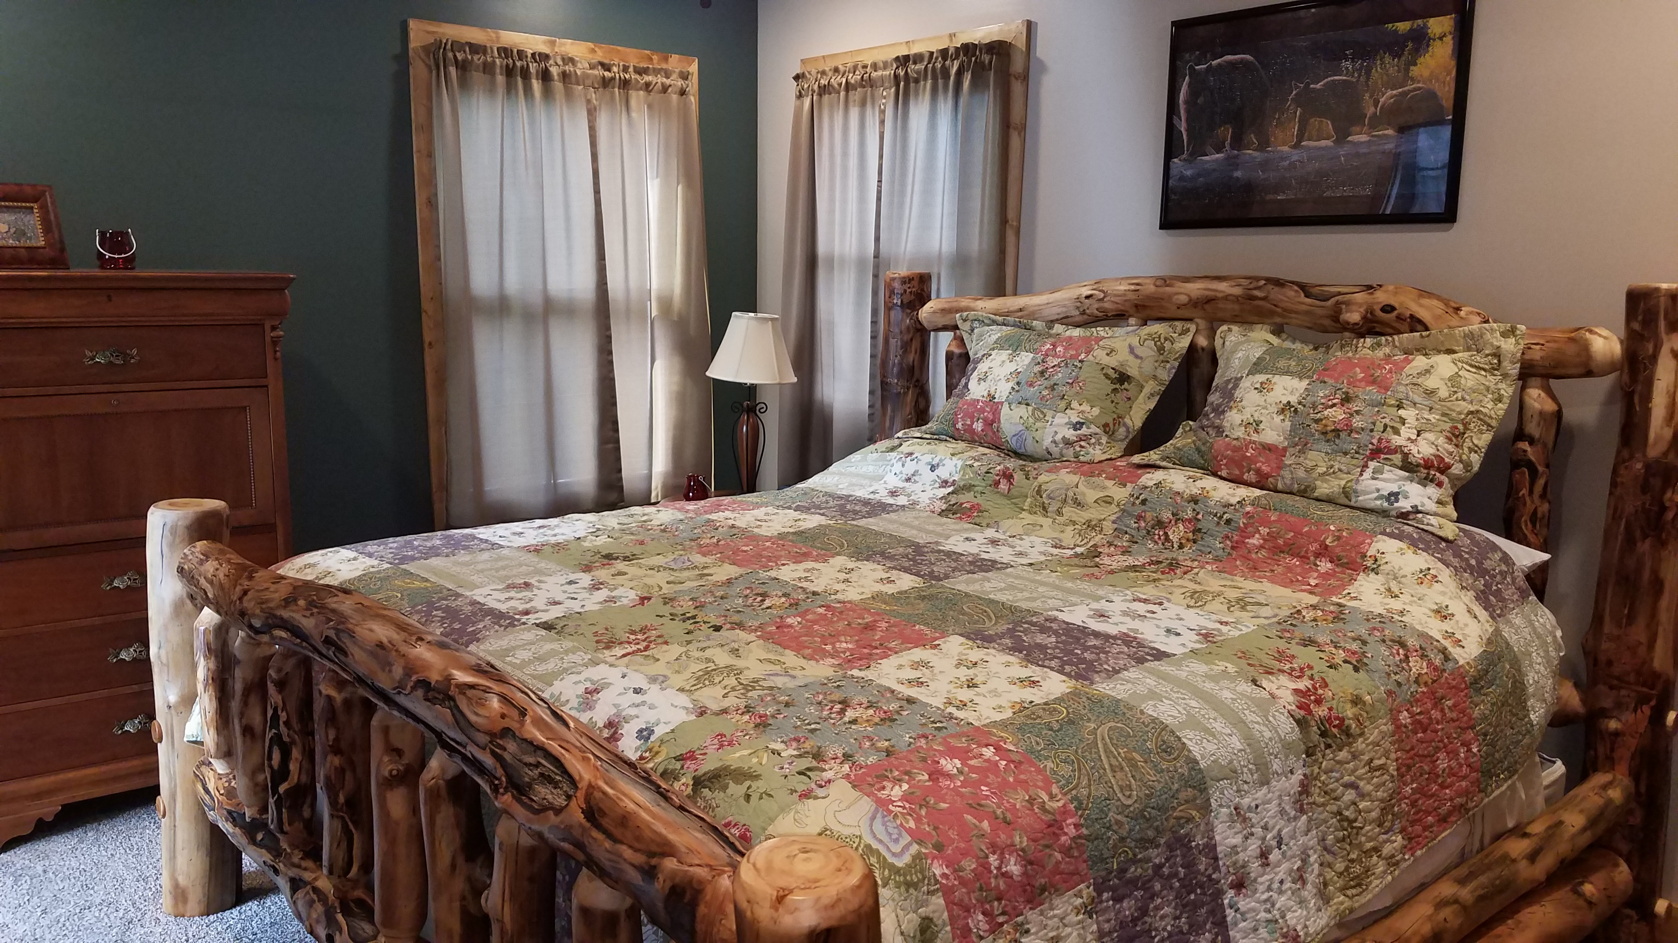
Page 2
CVOC FALL 2018
Many of our homeowners are rebuilding log homes as well as homes with “rustic” interiors. If you are interested, we have a great connection for Amish Built Rustic Furniture. Handcrafted Mortise and Tenon Custom Rustic furniture built by the Amish in Pennsylvania out of White Cedar and Colorado Aspen. Available items are beds, bedroom sets, live edge dining room tables, Colorado aspen lamps. The tables are custom built to your specifications to meet your particular needs. We have several homeowners with personal experience with these products and they have recommended that we share the information with our owners. If you are interested in this type of product you can obtain more information by calling Bryan Brainard at 610-715-9734 or sending an email to BryanBrainard@verizon.net. The pictures are just a small example of the products available.

Custom Dining Tables & lamps
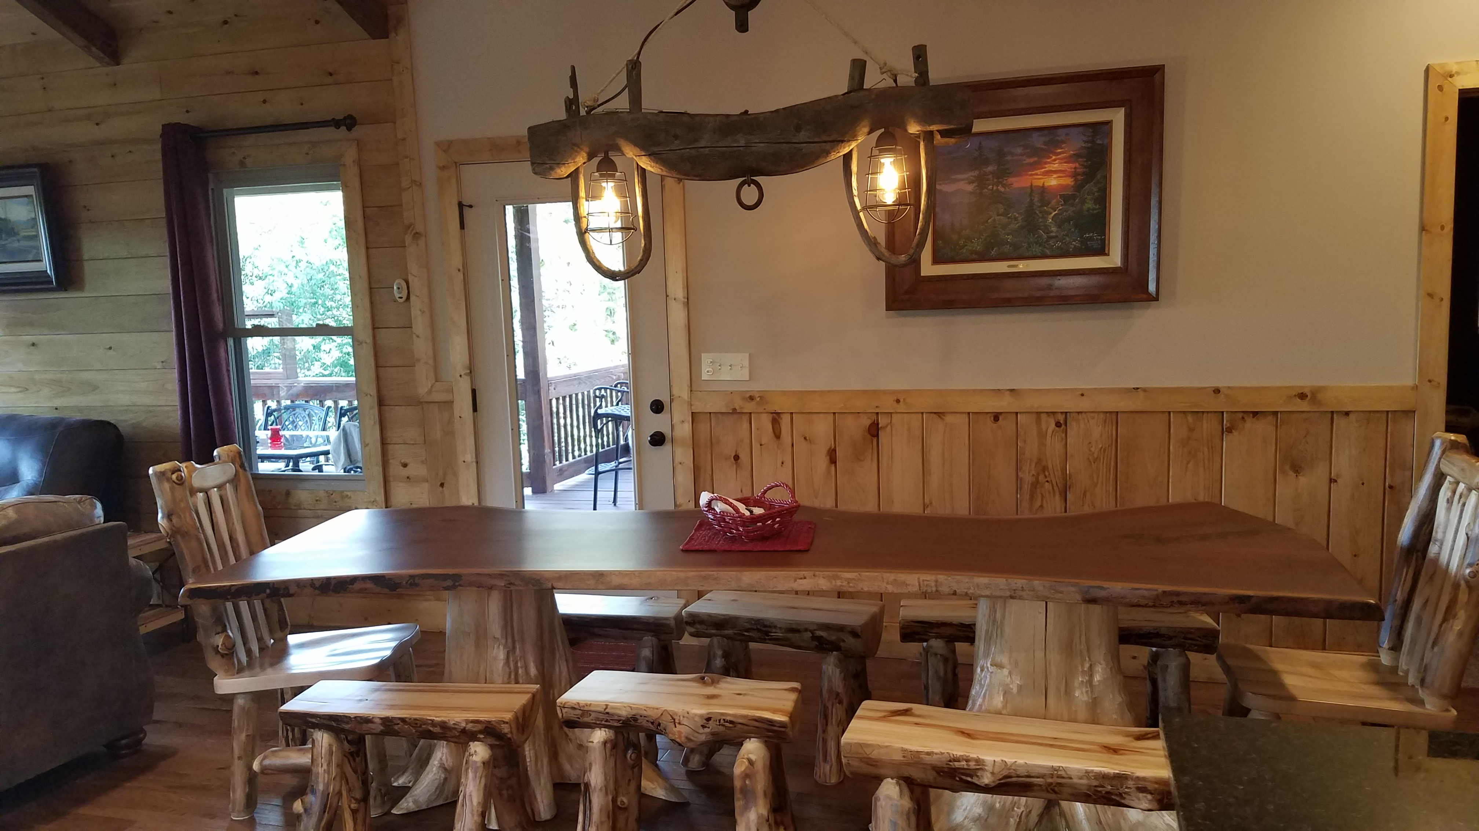

2019 ANNUAL OWNERS WEEKEND

VEGETATION CLEAN-UP

In CV we have a little gem that we often forget or take for granted. Ober Gatlinburg! Why not visit during their Oktoberfest? They offer fantastic food, a bier garten, interesting shops and who can resist the oompah band? This festival has something for everyone in the family and gives you a great opportunity to check out everything Ober has to offer. The mountain coaster is one of the absolute best in our area and we have heard rumor that they are launching a “bumper boats” on ice soon. That is bound to be amazing fun! How can you miss with snow tubing and ice skating, shops and amusements? Fall is a great time to visit our mountain neighbor and recommend it to your guests for year- round fun for the whole family.
Rebuilding…wow there is so much going on in CV. We are blessed to have so many beautiful homes being rebuilt and that our homeowners are the kind to reach out to each other and share valuable information. Remember that under the Covenants and Restrictions you need to turn your plans and permits into the HOA for approval prior to building. One issue that has come up for some is the need for fire suppression systems. Please have discussions with your contractors regarding the code for fire suppression. It is much easier to make the plans and budget BEFORE you have all the interior walls finished and your waiting on inspection. TN Water is working closely with homeowners to meet the water requirements and there are a few local companies that are doing system installs. If you find yourself in the position requiring a system, call the office and we can connect you with others that have already been down that road. Another issue has been the damaged trees. IF you have damaged trees on your property and not in the easements, you will be required to take those down. The easement will be the county. See if Chalet Village Firewise Facebook has the info you need.

As you all realize, as a community, we are still in the “growing” stages and still have much growth to come. We planned this summer’s pool schedule based on the rebuilding and the volume of rentals. We also had to be mindful of our operating budget. The schedule we had for 2018 worked very well for the most part. I know some wish all the pools were open more but this year, it was not practical. The North pool had a few strong weekends but only ONE weekend that exceeded 50 people. The average was less than 12 a day. I personally spoke with many guests at the pools and explained our reasoning and most everyone was very understanding and happy to have the facilities we had available. As we explained in the Owners meeting, this is an on-going learning lesson and as properties are rebuilt, we will continue to re-evaluate and adjust to meet the needs of everyone and be good stewards of the HOA funds. We thank you and appreciate your patience and understanding as we learn and grow for the best of CVOC.

REBUILD INFORMATION

SUMMER AT THE POOLS
Page 3
CVOC FALL 2018


OBER GATLINBURG

“OKTOBERFEST” at Ober includes Bavarian Fun, music and food-Sept 21-October 28
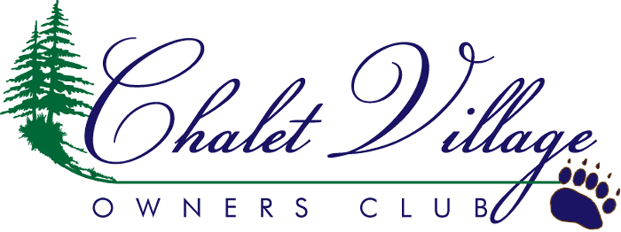
We’re on the Web!
www.chaletvillageownersclub.com
Chalet Village Owners Club, Inc
1319 S. Baden Drive
Gatlinburg, TN 37738

Phone 865-436-4440
Fax 865-325-1136
E-mail cvowners@aol.com

A word from CVOC President-Ken Webster
CVOC FALL 2018
Page 4
Fall is upon us once again! It has been a busy year at the Owner's Club. We were pleased to be able to reopen the North Clubhouse for the first time since our wildfires of 2016. The pools and Clubhouse look great! Drive by and take a look if you haven't already had the opportunity.
Needless to say, the Homeowner's Association, as well as you our homeowners, is still dealing with the aftermath of the fires in 2016. There are many new houses that have been rebuilt, and more in various stages of the construction process. I would urge all owners who are not rebuilding at the present time to take a look at the growth that has sprouted up on your lot to make sure it doesn't get out of control before you rebuild. We continue to have to deal with trees that are dying or dead. This is a fact that we will probably be dealing with for several more years. As I have found from experience it is easier to deal with the dead trees before you start building rather than waiting until you have a house in place. As you rebuild please take a look at the "Firewise" practices information that is available. Now is a good time to incorporate some of these practices in your construction and landscape planning. The use of these practices might help in the event of a future fire. There are pamphlets available at all the clubhouses regarding firewise building materials, landscaping and contact information on participation in our Chalet Village Firewise program.

